SCREENSHOTS

SCREENSHOTS

Mouna Giri

2017

1. When the program is executed, the menu is displayed

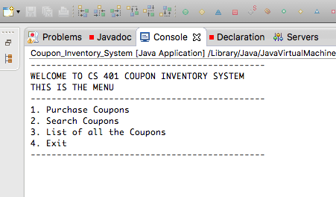

1. Under Purchase Coupons, adding the coupons through the input file by providing the path name. It displays a message after the coupons are added.

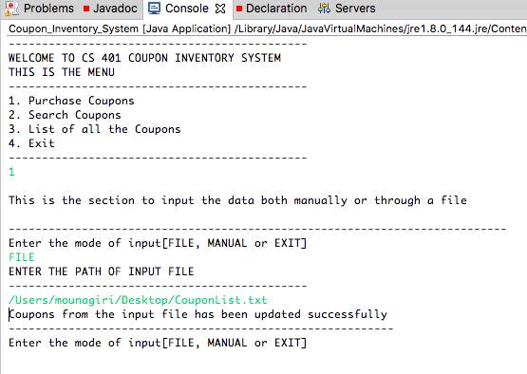

1. Under Purchase Coupons, adding the coupons through manual method by entering the coupon parameter. It displays a message after the coupons are added.



1. Exiting the manual entry mode

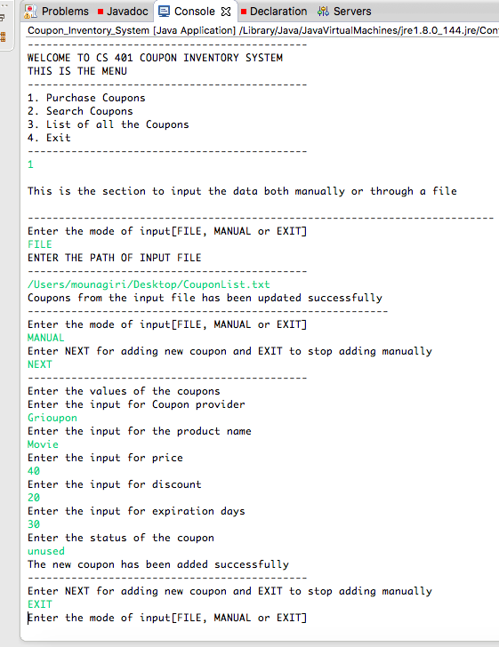

1. Exiting the purchase coupon module

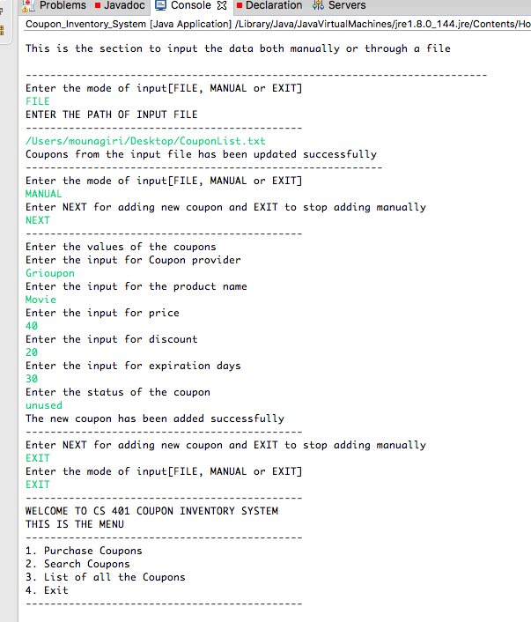

1. When we type 2 and in the search coupon – first we enter the Coupon provider name and second time we type Product name. Both the results are there in the below screenshots

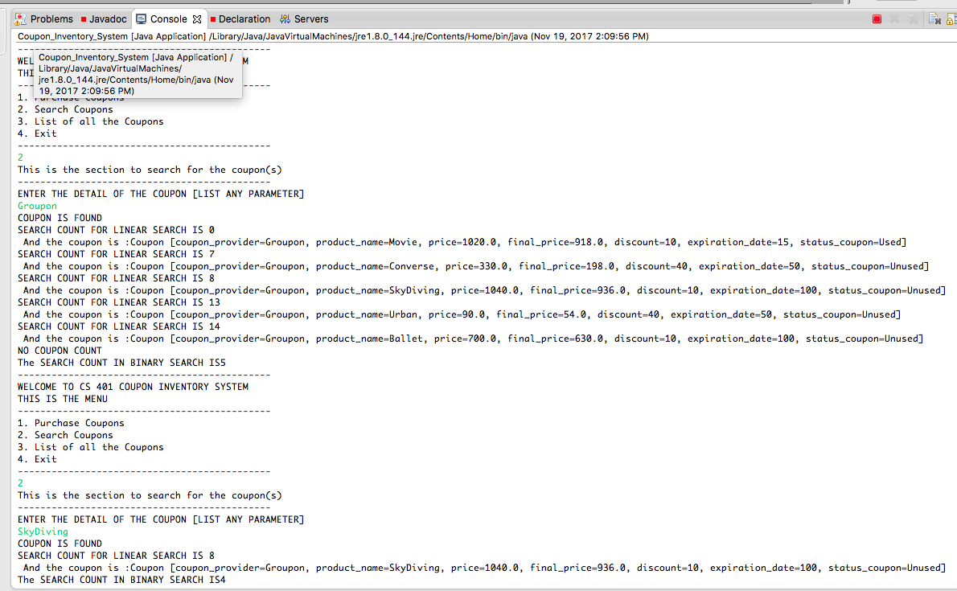

1. When the coupon is not found in the list.

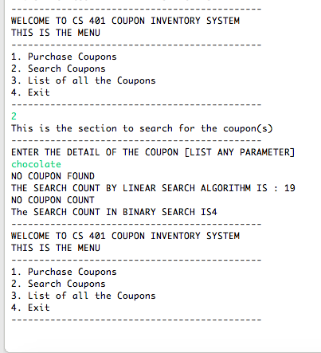

1. Type 3 for Listing the coupons in ascending order.

LIST ORDER BASED ON COUPON PROVIDER.

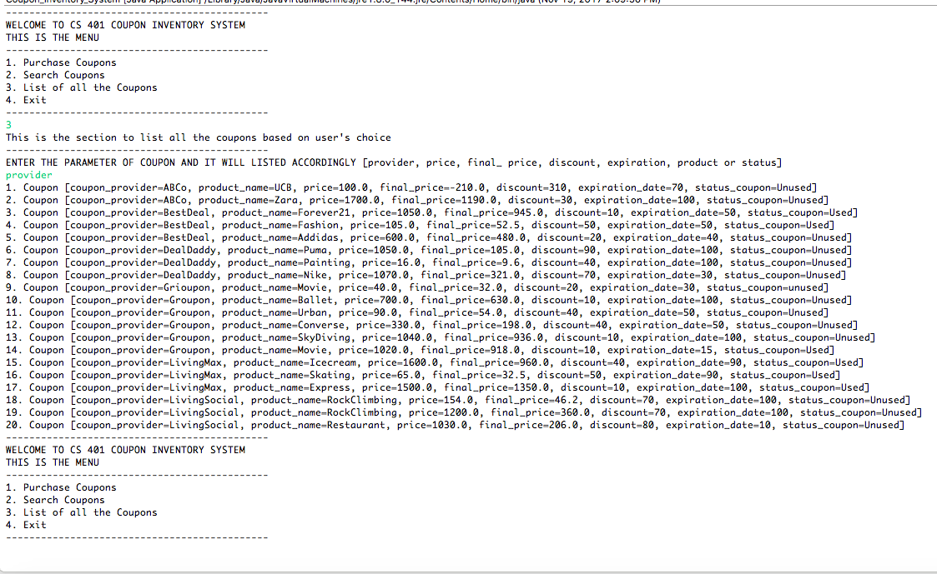

1. LIST ORDER BASED ON COUPON PRODUCT NAME

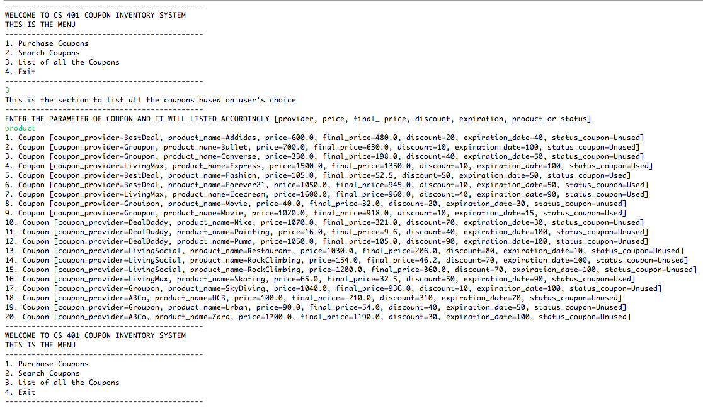

1. LIST ORDER BASED ON STATUS

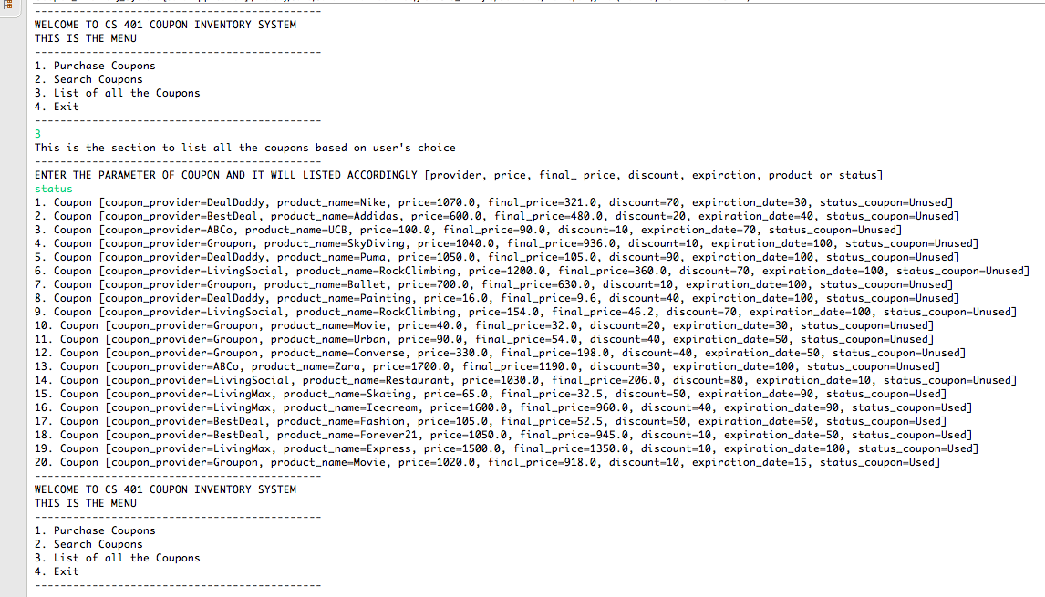

1. LIST ORDER BASED ON EXPIRATION DAYS

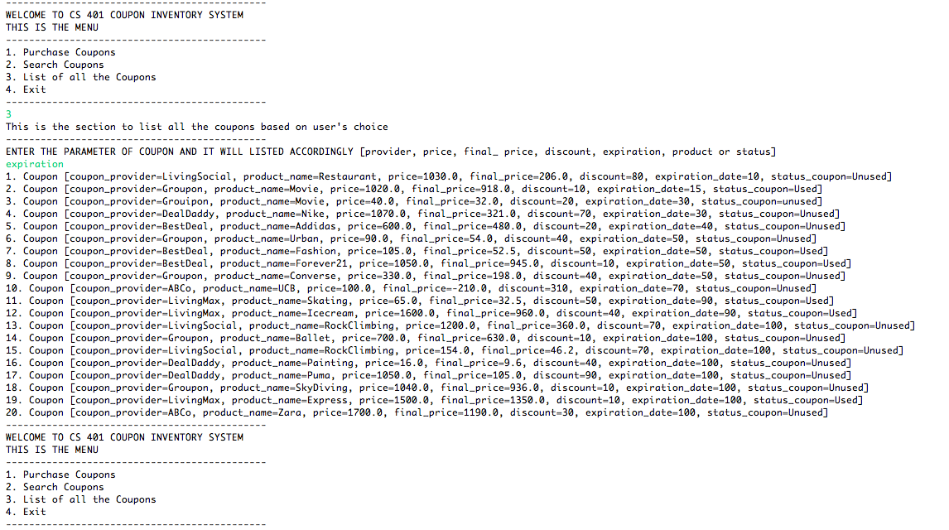

1. LIST ORDER BASED ON COUPON PRICE

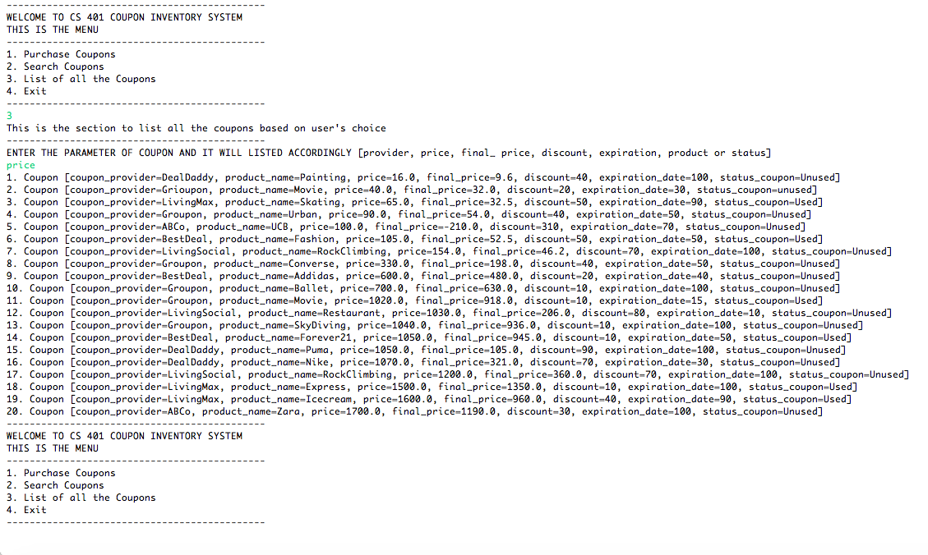

1. LIST ORDER BASED ON COUPON FINAL PRICE

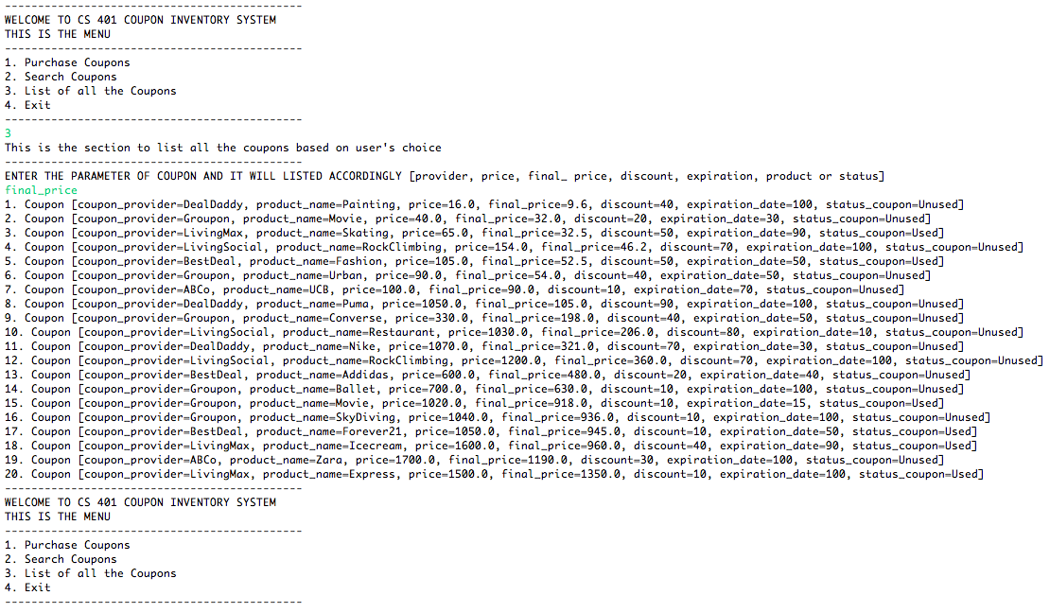

1. LIST ORDER BASED ON COUPON DISCOUNT

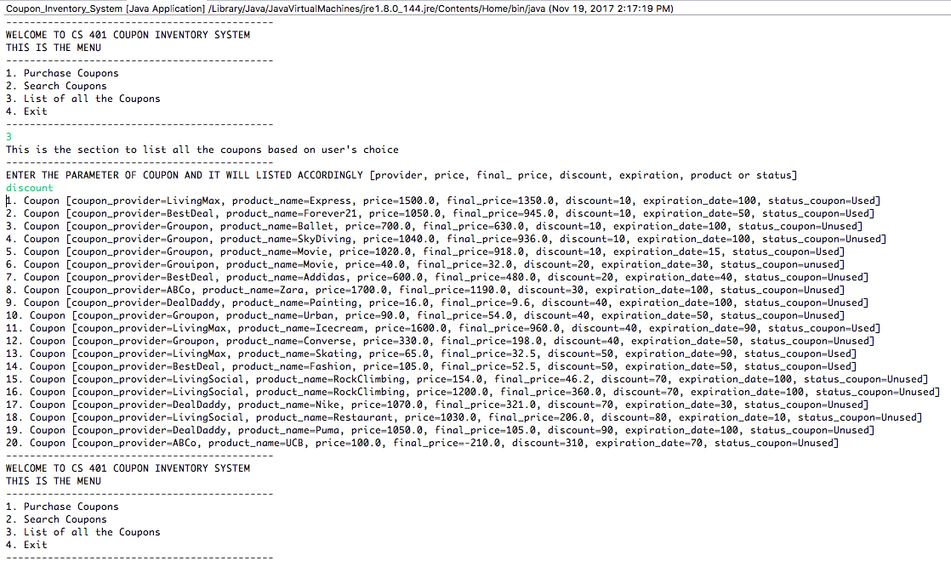

1. WHEN YOU TYPE 4 TO EXIT

